

**Lab Report: Electrical Circuits (CSE 209)**

**Expt. No: 03**

**Title: Measurement of equivalent resistance and verification of current rule.**

**Submitted by-**

Name: Md.Minhajur Rahman

ID: 2023-3-60-301

Section- 01

Group- 05

**Submitted to-**

Dr. Sarwar Jahan

Associate Professor

Department of Computer Science & Engineering

East West University

**Date of Performance**: 12/11/24

**Date of Submission:** 19/11/24

**Title:** **Measurement of equivalent resistance and verification of current rule.**

**Objective:**

In any electrical network, it may require calculating the equivalent resistance between two terminals. Sometimes it becomes cumbersome to calculate the equivalent resistance through theoretical calculation. It is very simple to measure the equivalent resistance through an experiment using Ammeter and Voltmeter.

The aims of this experiment are:

1. To measure the equivalent resistance through experiment, and then compare that with that of theoretical calculation, and
2. (ii) To verify the current division rule.

**Equipment and Accessories:**

* 1. Voltmeter, Ammeter
  2. DC Power Supply (0-30V DC)
  3. Resistors
  4. Breadboard

**Part I:**

**Circuit Diagrams:**

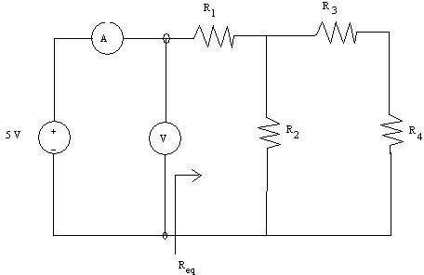

**Fig.1**

**Calculation:**

For Figure 1 ,

R1 = 0.996 kΩ

R2 = 3.255 kΩ

R3 = 4.702 kΩ

R4 = 9.882 kΩ

R3+R4 = (4.702+9.882) kΩ

= 14.584 kΩ = R’ Req = R1(R2||R’)

=(3.255||14.584)+0.996 kΩ

= 3.657 kΩ

**Data Table:01**

|  |  |  |
| --- | --- | --- |
| **Voltage source** | **Voltage (Vab)** | **Current (I)** |
| 1 | 1.069V | 0.3mA |
| 2 | 2.036V | 0.5mA |
| 3 | 3.086V | 0.7mA |
| 4 | 4.115V | 1.2mA |
| 5 | 5.125V | 1.5mA |

Here is the simulation of

PSPICE of Figure 1

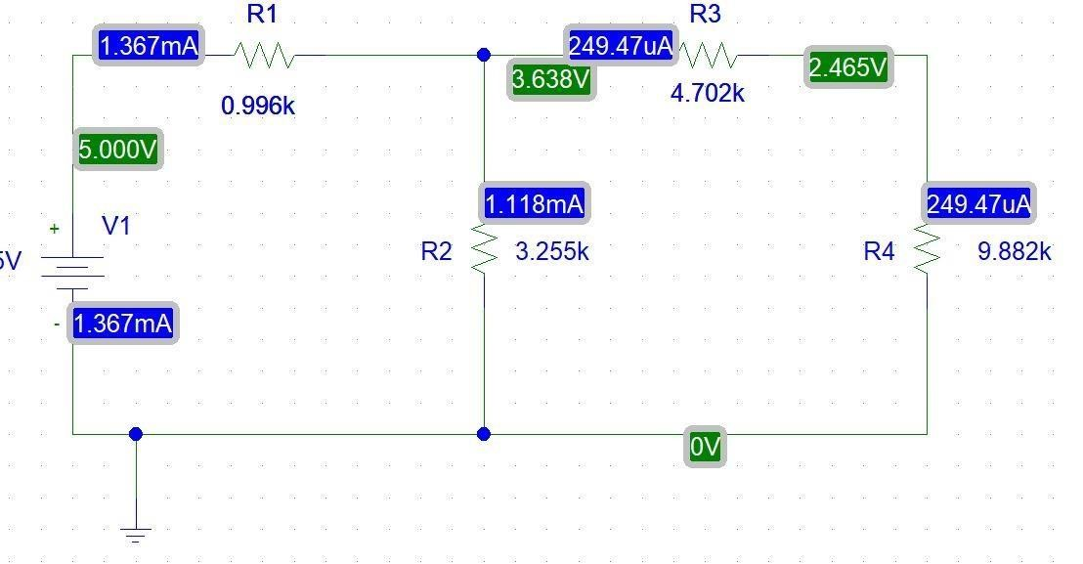

.

**Calculation:**

**For V1 = 1V,**

V = 1.064

I = 0.3

Req = V1 / I = 1.064 / 0.3 = 3.563 kΩ

**For V2 = 2V,**

V = 2.036

I = 0.5

Req = V2 / I = 2.036 / 0.5 = 4.072 kΩ

**For V3 = 3V,**

V = 3.086

I = 0.7

Req = V3 / I = 3.086 / 0.7 = 4.408 kΩ

**For V4 = 4V,**

V = 4.115

I = 1.2

Req = V4 / I = 4.115 / 1.2 = 3.429 kΩ

**For V5 = 5V,**

V = 5.125

I = 1.2

Req = V5 / I = 5.125 / 1.2 = 4.27 kΩ

**Part-II:**

**Circuit Diagrams:**

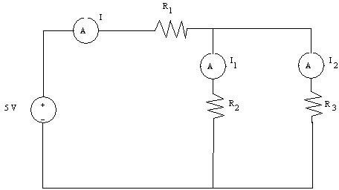

**Fig.2**

R1 = 0.996 kΩ

R2 = 3.255 kΩ

R3 = 4.702 kΩ

Req = R1 + (R2 || R3)

= 0.996 + ((3.225 X 4.702) / (3.255 + 4.702)) kΩ = 2.909 kΩ

**#Theoretically compute the currents I, I1, and I3.**

**For Vs  = 1V ,**

I = Vs / Req

= 1 / 2.909mA

= 0.344 mA

I1 = I * R3 / (R2 + R3)

= (0.344*4.702) / (3.255+4.702) mA

= 0.203 mA

I2 = I * R2 / (R2 + R3)

= (0.344*3.255) / (3.255+4.702) mA

= 0.141 mA

**For Vs  = 2V ,**

I = Vs / Req

= 2 / 2.909mA

= 0.688 mA

I1 = I * R3 / (R2 + R3)

= (0.688*4.702) / (3.255+4.702) mA

= 0.407 mA

I2 = I * R2 / (R2 + R3)

= (0.688*3.255) / (3.255+4.702) mA

= 0.281 mA

**For Vs  = 3V ,**

I = Vs / Req

= 3 / 2.909mA

= 1.031 mA

I1 = I * R3 / (R2 + R3)

= (1.031*4.702) / (3.255+4.702) mA

= 0.609 mA

I2 = I * R2 / (R2 + R3)

= (1.031*3.255) / (3.255+4.702) mA

= 0.422 mA

**For Vs  = 4V ,**

I = Vs / Req

= 4 / 2.909mA

= 1.375 mA

I1= I * R3/ (R2+ R3)

= (1.375*4.702) / (3.255+4.702) mA

= 0813 mA

I2= I * R2/ (R2+ R3)

= (1.375*3.255) / (3.255+4.702) mA

= 0.562 mA

**For Vs  = 5V ,**

I = Vs / Req

= 5 / 2.909mA

= 1.719 mA

I1= I * R3/ (R2+ R3)

= (1.719*4.702) / (3.255+4.702) mA

= 1.016 mA

I2= I * R2/ (R2+ R3)

= (1.719*3.255) / (3.255+4.702) mA

= 0.703 mA

Here is the Simulation with PSPICE of Fig 2

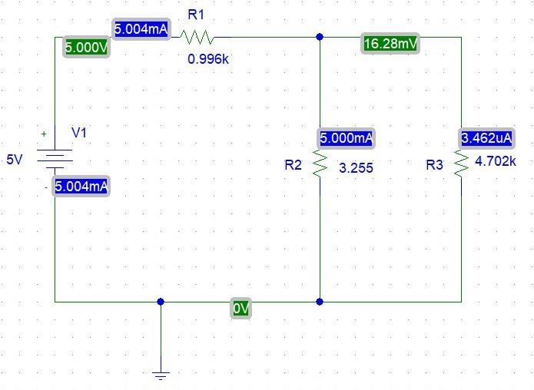

**Data Table:02**

|  |  |  |  |
| --- | --- | --- | --- |
| **Source Voltage** | **The current through the R1**  **resistor (I)** | **The current through the R2**  **resistor (I1)** | **The current through the R3**  **resistor (**I2) |
| 1 | 0.4mA | 0.2mA | 0.19mA |
| 2 | 0.6mA | 0.3mA | 0.29mA |
| 3 | 1.1mA | 0.5mA | 0.6mA |
| 4 | 1.5mA | 0.8mA | 0.65mA |
| 5 | 1.9mA | 1mA | 0.78mA |

Here we can see error between measured and calculated value. This is discrepancy of the resistors which were provided for the lab and those happened mainly because of instrumental and human error.

**Error Analysis:**

For Vs  = 5V,

Theoretical values of I= 1.719 mA

Experimental values of I= 1.9 mA

**Error** = |((1.719 – 1.9 ) /1.9)|*100 = 9.5 %

For Vs  = 5V,

Theoretical values of I1 = 1.016 mA

Experimental values of I1 = 1 mA

**Error** = |((1.016 – 1)/1)|*100 = 1.6%

For Vs  = 5V,

Theoretical values of I2 = 0.703 mA

Experimental values of I2 = 0.78 mA

**Error = |**((0.703-0.78)/0.78)|*100 **=** 7.7%

